**Work In Progress**

**The Misfits**

**TEAM MEMBERS:**

**Aayush Rajbhandari**

**Aman Kumar Shrestha**

**Pratiksha Manandhar**

**Sanjeev Lamsal**

**Top Bahadur Rana**

**Table of Content**

1. **Initiation Phase**

**1.1** Project Charter

· Version Control

· Project Justification

· Project Scope

· Project Assumption

· Rules & Responsibilities

**1.2** Meeting Minutes

**2. Planning Phase**

**2.1** Belbin Analysis

·Team Belbin’s Analysis

·Individual Belbin’s Analysis

**2.2** Skills Audit

·Team Skills Audit

·Individual Skills Audit

**2.3** Project Management (MS Project)

-Gantt Chart

-Timeline

-Network Diagram

-Calendar

-Resource Sheet

·Change Working Time

Communication Tool Used

.  **3. Execution**

**3.1** Entity Relationship Diagram

· EERD

· ERD

· Final Composite

· Logical Table

**3.2** Use Case Diagram

· Overview Use Case Diagram

· Customer Use Case Diagram

· Trader Use Case Diagram

· Admin Use Case Diagram

**3.3**Requirement Catalogue

· Functional Requirement

· Non-Functional Requirement

. **3.4** Logo Design

. **3.5** Wireframe

**3.6** Product Development

- Website Homepage  
- Signup Page

- About us  
- Sign In Page

**Initiation Phase**

**1.1 Project Charter**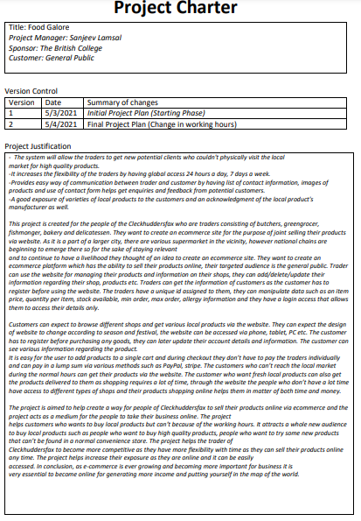

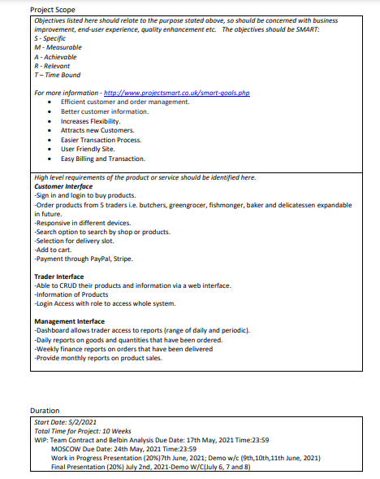

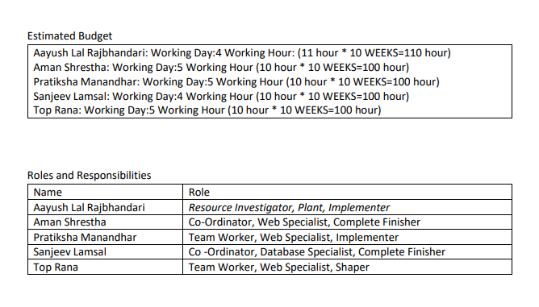

**1.2 Meetings and Minutes**

|  |  |  |  |  |  |  |
| --- | --- | --- | --- | --- | --- | --- |
| **Week** | **Date** | **Place** | **Meeting Days** | **Meeting time** | **Meeting Agendas** | **Participants** |
| **Week 2** | **03/05/2021** | **Google Meet** | **Monday** | **12:00 to 2:00** | **Project Charter Completion.** | **Aayush Lal Rajbhandari ,Aman Kumar Shrestha ,Pratiksha Manandhar ,Top Bahadur Rana ,Sanjeev Lamsal** |
| **04/05/2021** | **Google Meet** | **Tuesday** | **11:37 to 1:23** | **Discussed Team Contract.** |
| **09/05/2021** | **Google Meet** | **Sunday** | **11:48 to 1:10** | **Discussed Skill Audit.** |
| **11/05/2021** | **Google Meet** | **Tuesday** | **6:33 to 7:34 pm** | **Finalised Skill Audit.** |
| **Week 3** | **19/05/2021** | **Google Meet** | **Sunday** |  | **Discussed ERD, EERD, Composite, Logical Table** | **Aayush Lal Rajbhandari ,Aman Kumar Shrestha ,Pratiksha Manandhar ,Top Bahadur Rana ,Sanjeev Lamsal** |
| **21/05/2021** | **Google Meet** | **Friday** |  | **Finalised ERD, EERD, Composite, Logical Table.** |
| **Week 4** | **24/05/2021** | **Google Meet** | **Monday** | **1:07 to 2:07** | **Discussed Use Case Diagram** | **Aayush Lal Rajbhandari ,Aman Kumar Shrestha ,Pratiksha Manandhar ,Top Bahadur Rana ,Sanjeev Lamsal** |
| **27/05/2021** | **Google Meet** | **Thursday** | **12:30 to 1:57** | **Finalised use case diagram** |
| **26/05/2021** | **Google Meet** | **Wednesday** | **12:30 to 2:23** | **Divided Wireframe between team members.** | **Aayush Lal Rajbhandari ,Aman Kumar Shrestha ,Pratiksha Manandhar ,Top Bahadur Rana ,Sanjeev Lamsal** |
| **27/05/2021** | **Google Meet** | **Thursday** | **12:30 to 2** | **Finalised Logo.** |
| **week 5** | **31/05/2021** | **Google Meet** | **Monday** | **1:03 to 2:30** | **Discussed MOSCOW.** | **Aayush Lal Rajbhandari Aman Kumar Shrestha Pratiksha lal Manandhar Top Bahadur Rana Sanjeev Lamsal** |

**Planning Phase**

**2.1 Belbin’s Analysis (Team)**

|  |  |  |
| --- | --- | --- |
| Version:1.0 Belbin’s Analysis Date reviewed:12/15/2021 | | |
| **Primary role** | Aayush Lal Rajbhandari | Resource Investigator |
| Aman Kumar Shrestha | Coordinator |
| Pratiksha Manandhar | Team Worker |
| Top Bahadur Rana | Team Worker |
| Sanjeev Lamsal | Coordinator |
| **Secondary role** | Aayush Lal Rajbhandari | Plant |
| Aman Kumar Shrestha | Web specialist |
| Pratiksha Manandhar | Web specialist |
| Top Bahadur Rana | Web specialist |
| Sanjeev Lamsal | Database specialist |
| **Least likely role** | Aayush Lal Rajbhandari | Implementer |
| Aman Kumar Shrestha | Complete finisher |
| Pratiksha Manandhar | Implementer |
| Top Bahadur Rana | Shaper |
| Sanjeev Lamsal | Complete Finisher |

**2.2 Skill Audit(Team)**

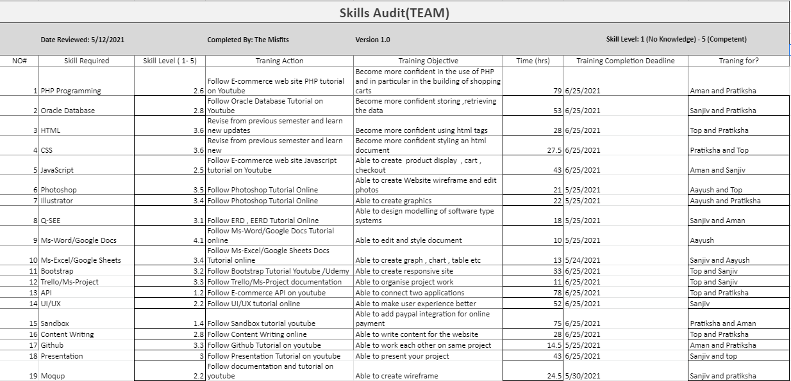

**2.2 Skill Audit (Individual)**

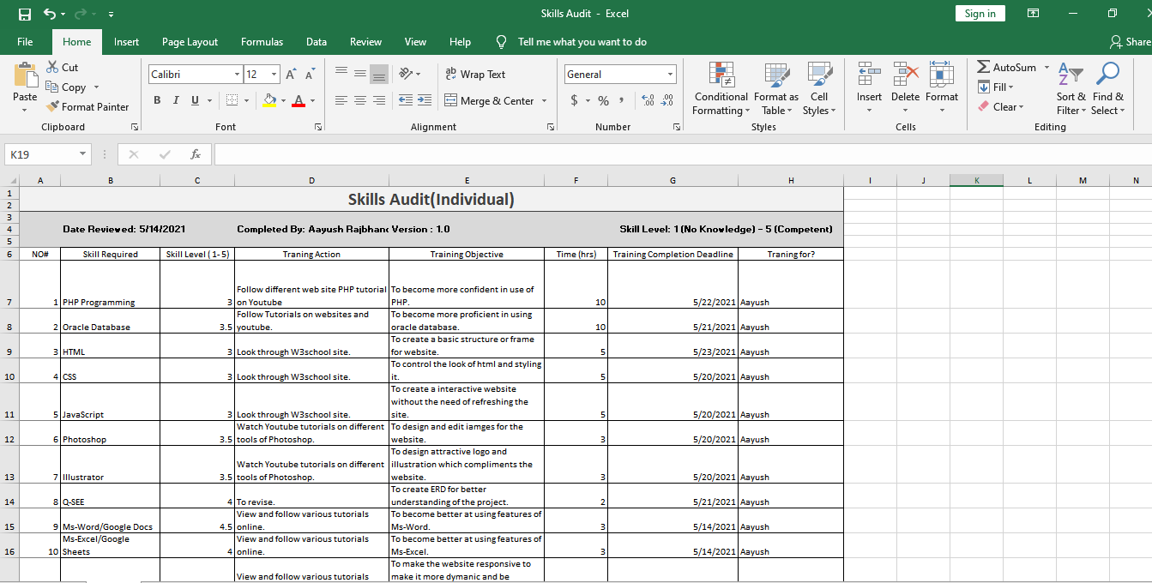

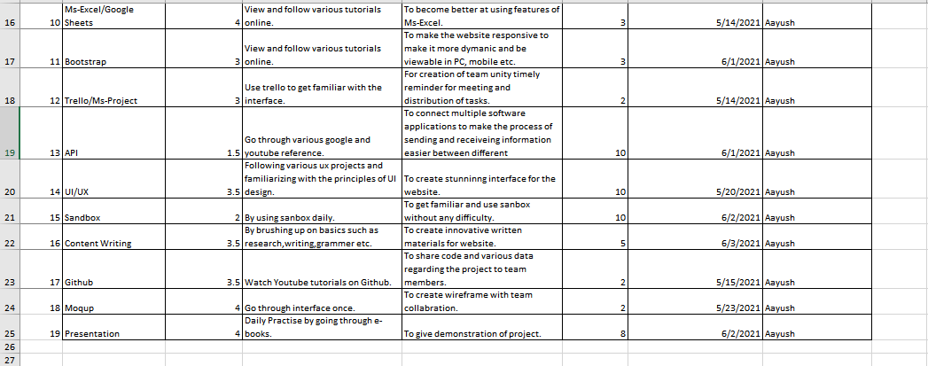

**2.3 MS-PROJECT**

**Gantt Chart:**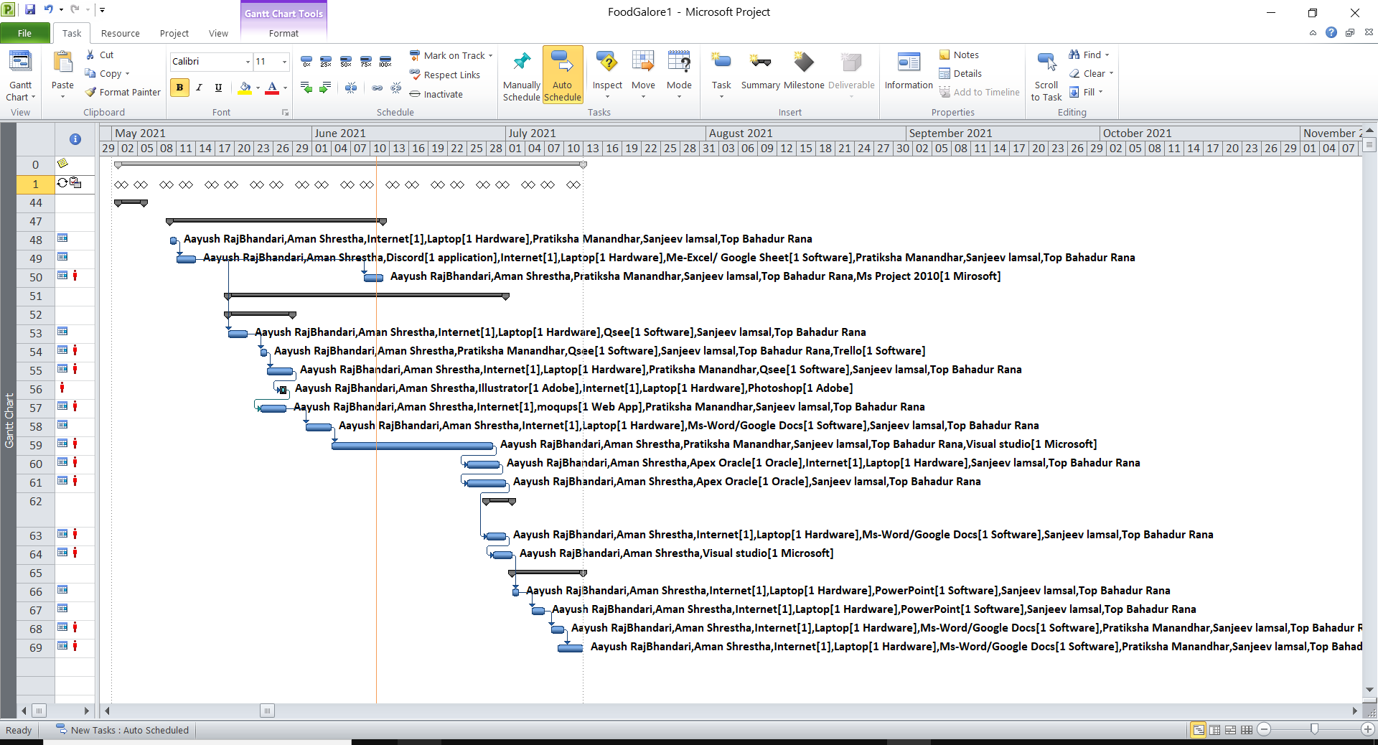

**Timeline**

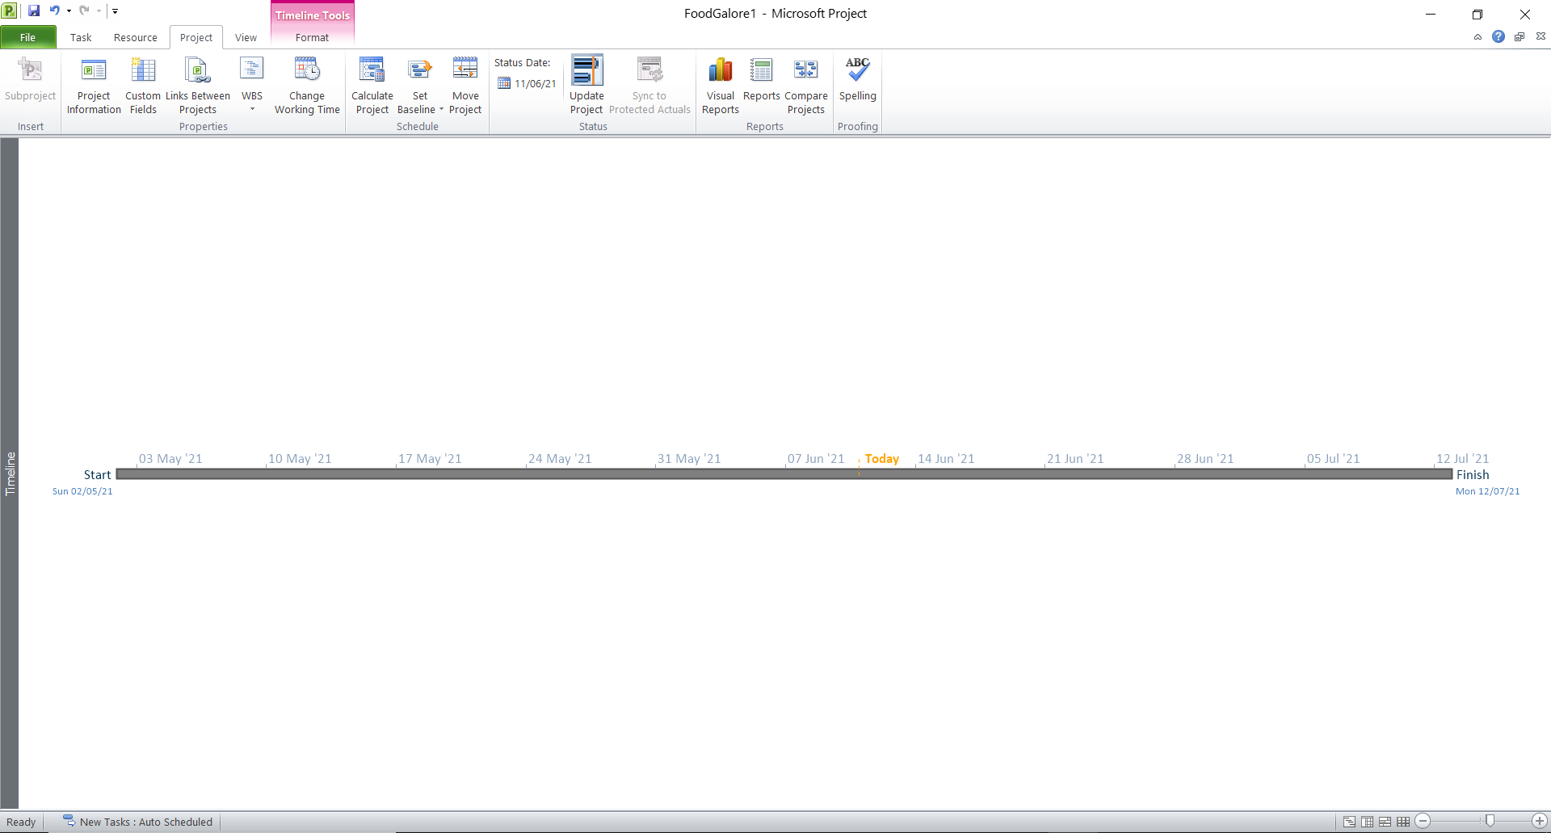

**Network Diagram**

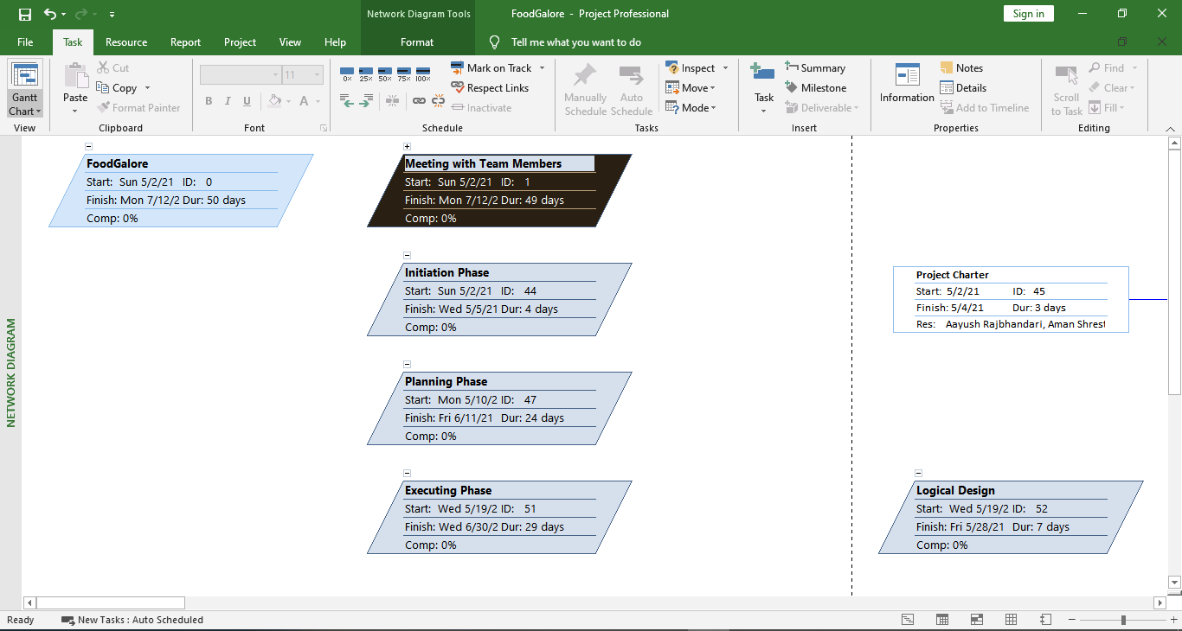

**Task Sheet**

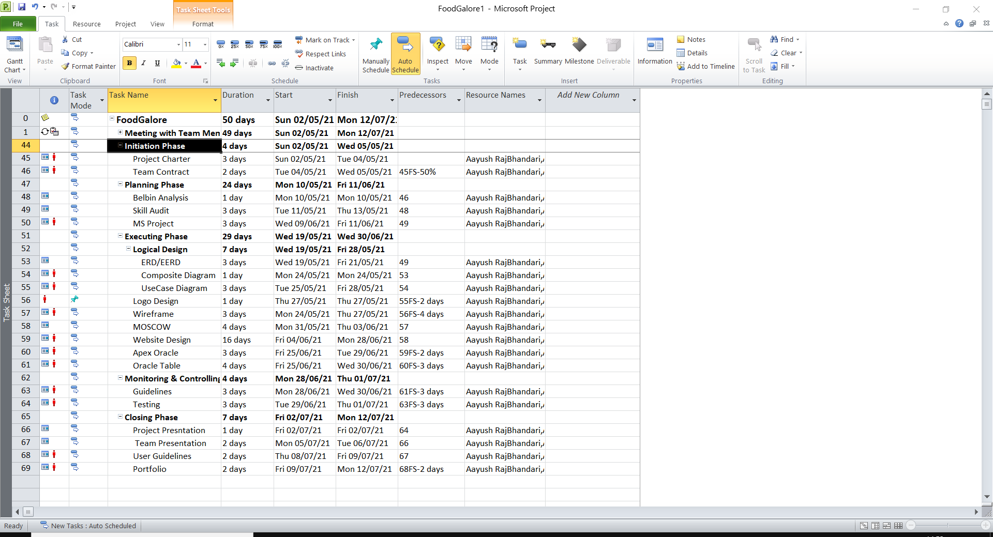

**Calendar**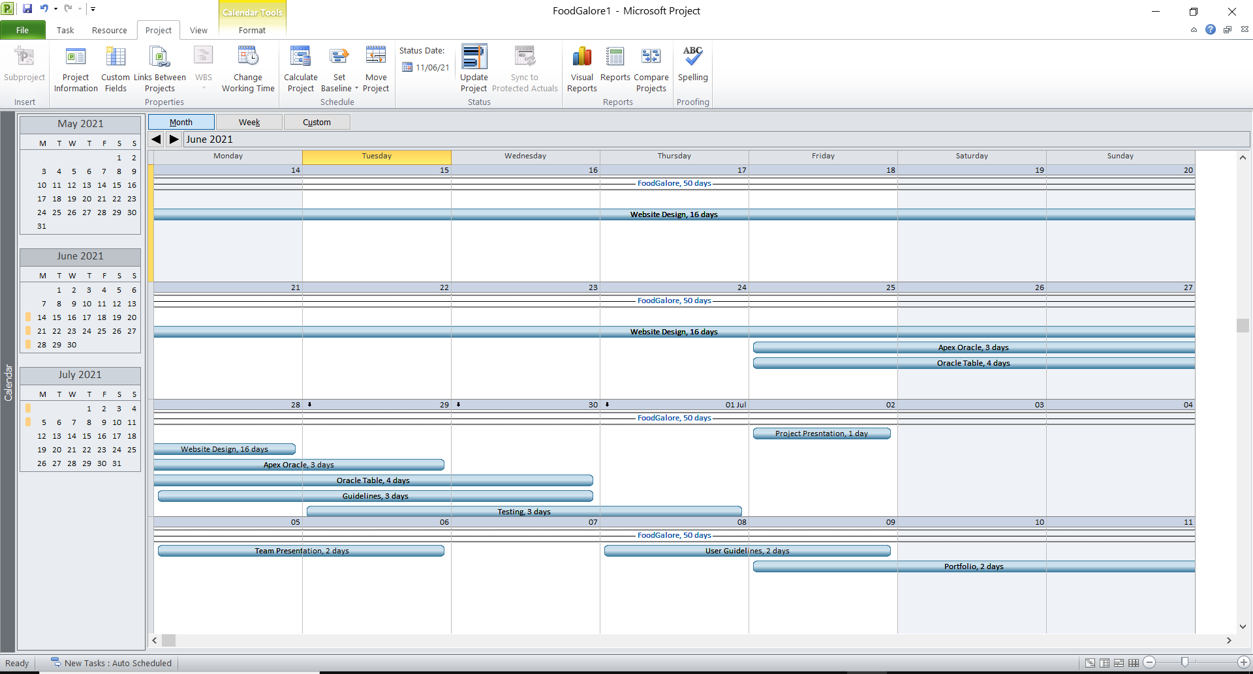

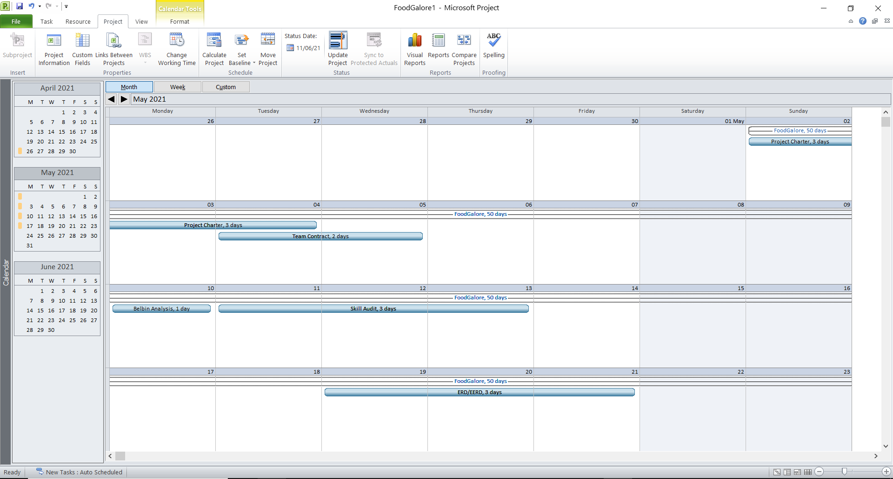



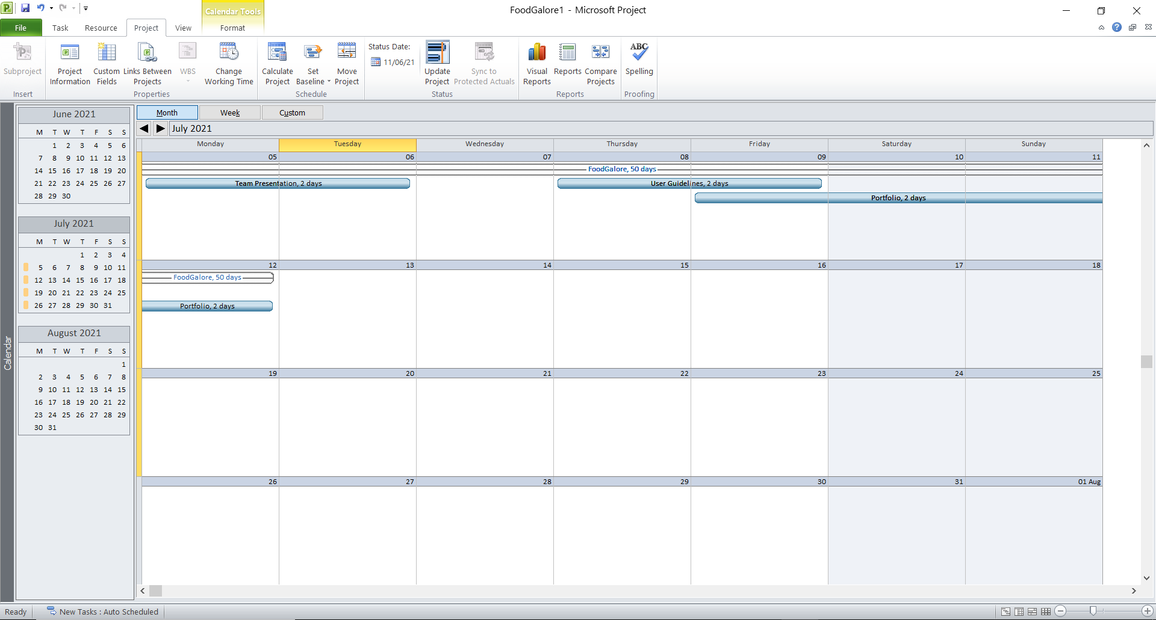

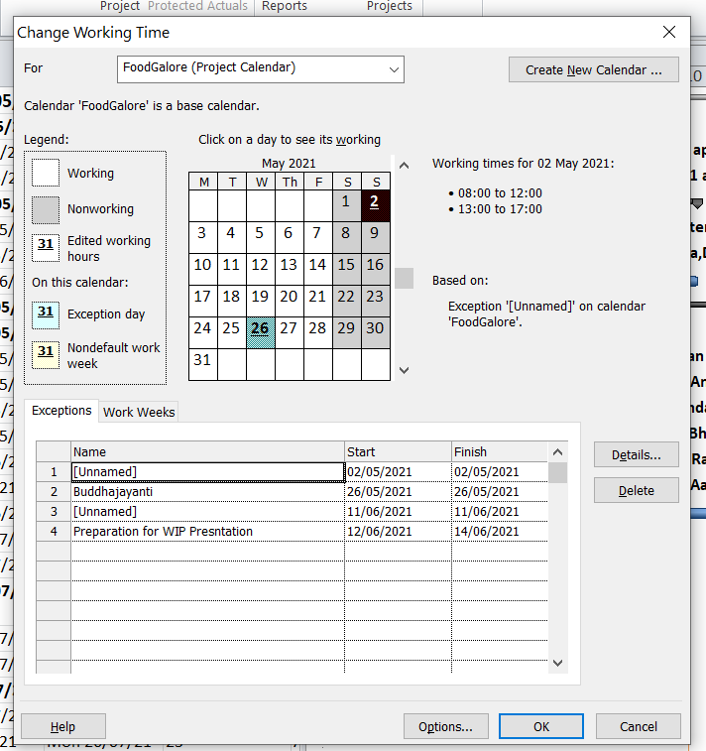

**Resource Sheet**

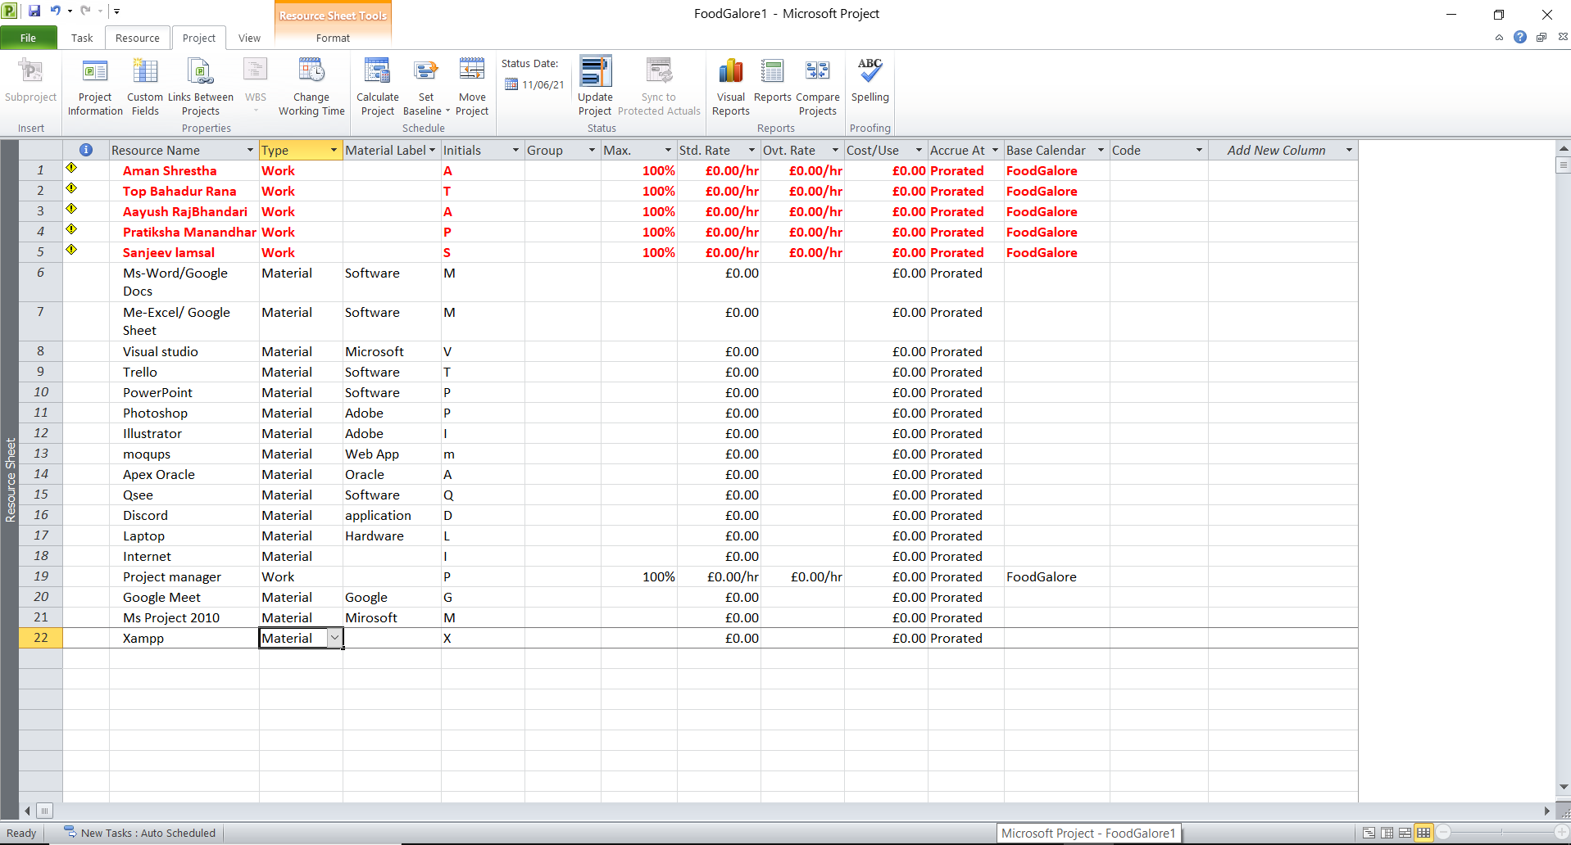

**2.4 Communication Tools Used**

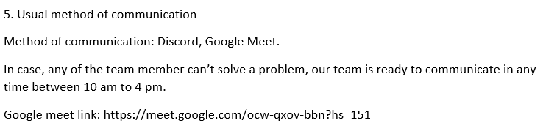

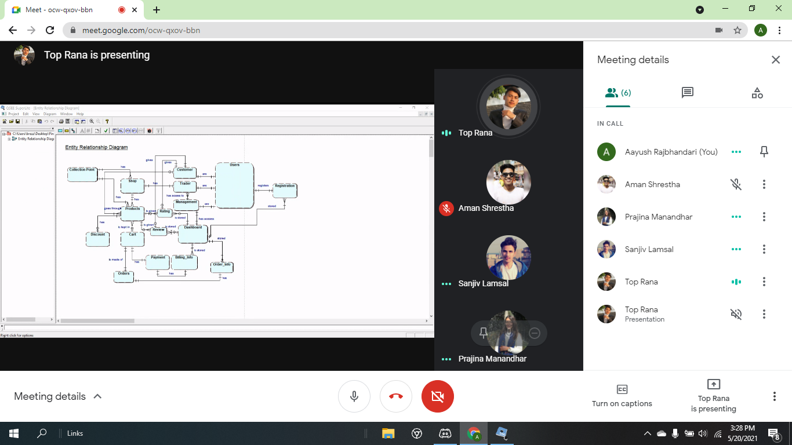

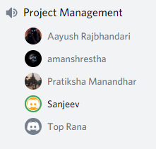

**Execution phase**

**3.1 Entity Relationship Diagram**

**EERD, ERD, Composite , Logital Table screenshot**

ERD

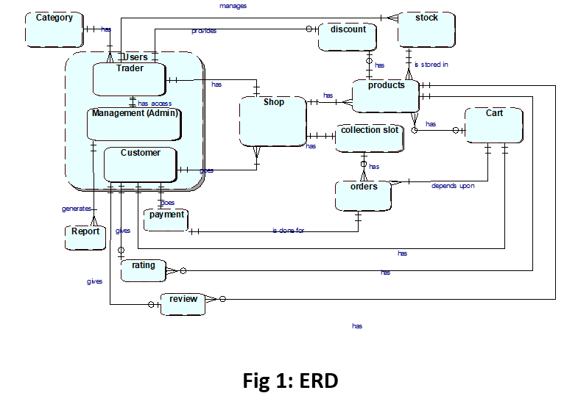

**EERD**

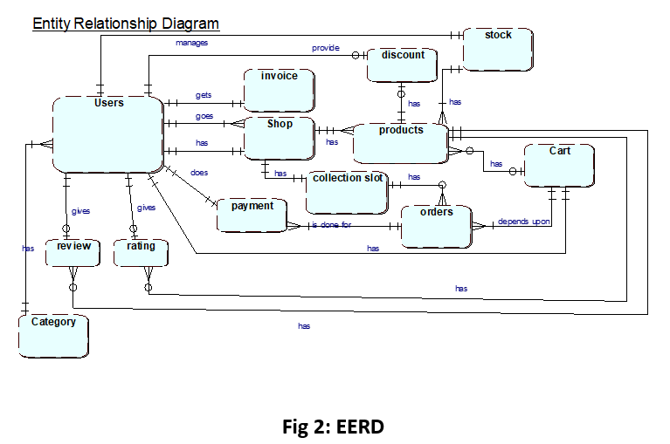

**EERD Composite**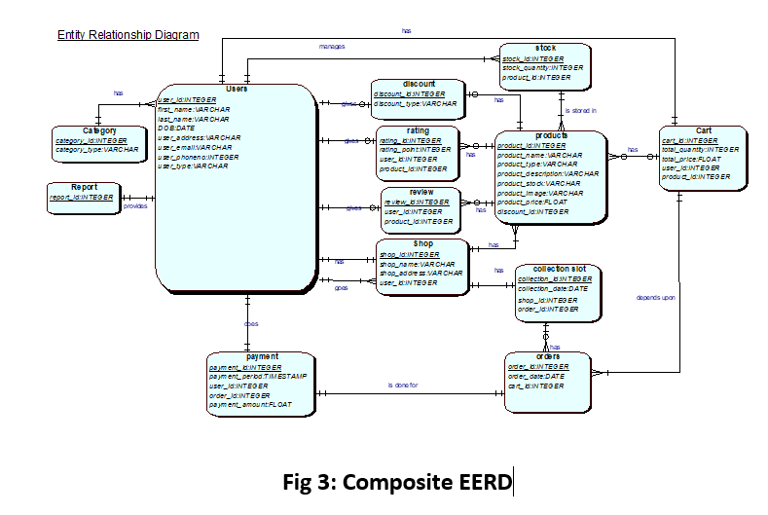

**Logical Table**

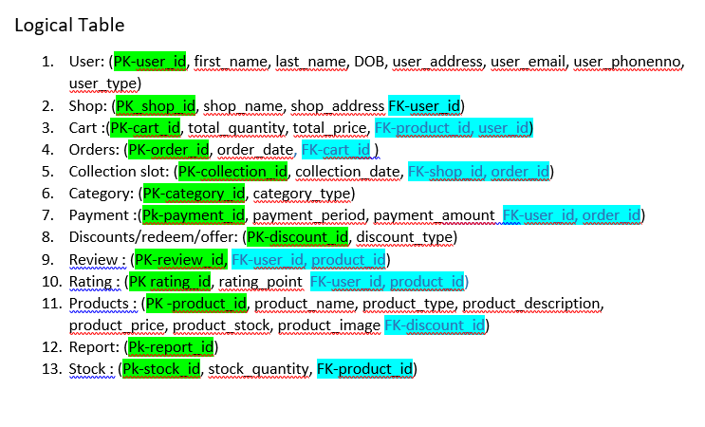

**3.2 Use Case Diagram**

**Customer**

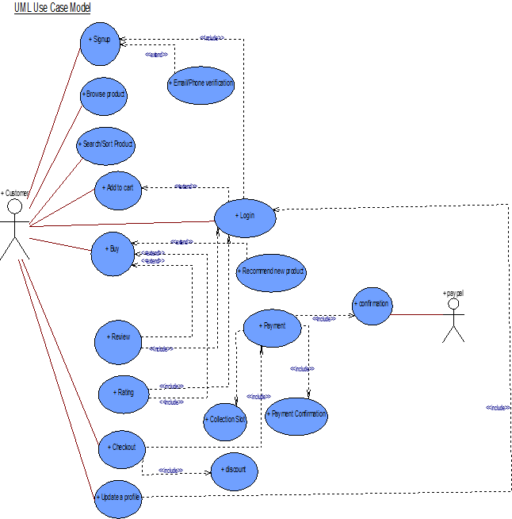

**Admin**

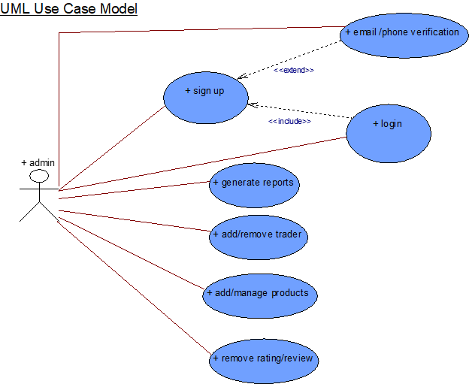

**Trader**

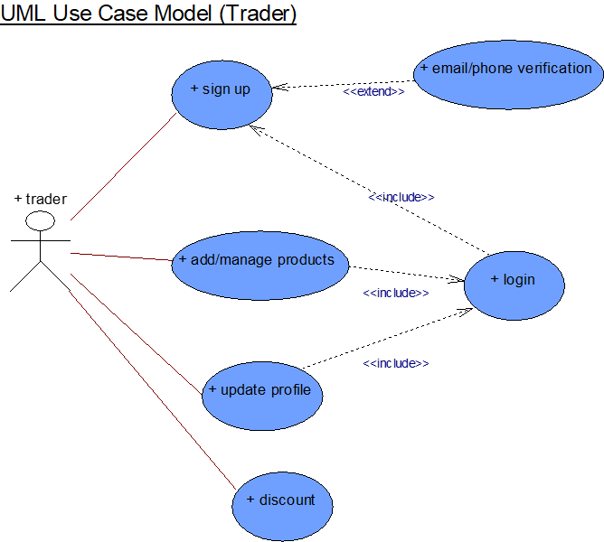

**Overview**

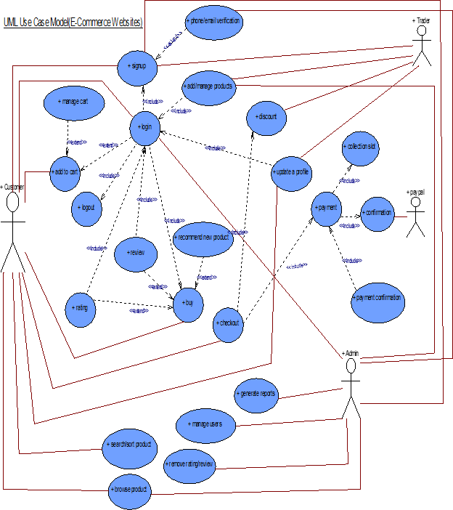

**3.3 Requirement Catalogue (Functional Requirement)  
All four interface screenshot  
A.Products**

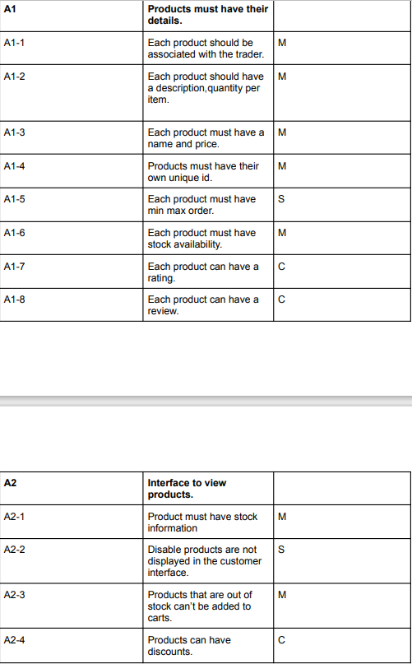

**B. Customer**

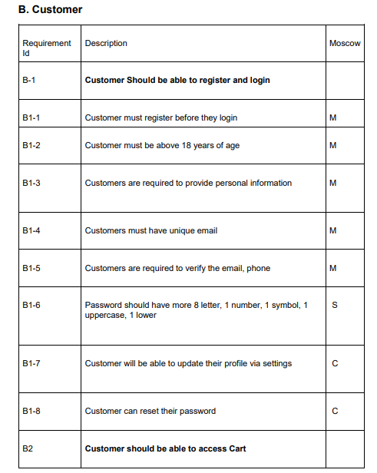

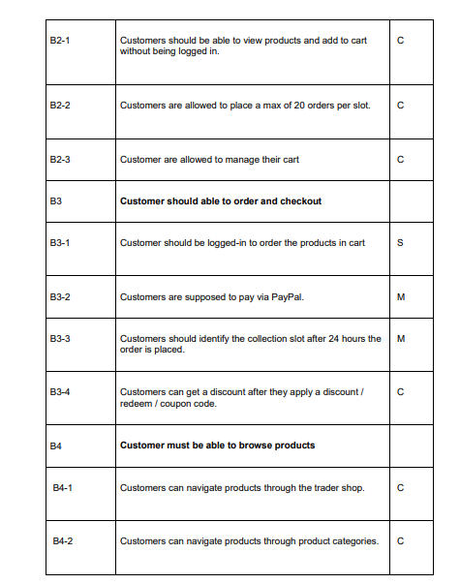

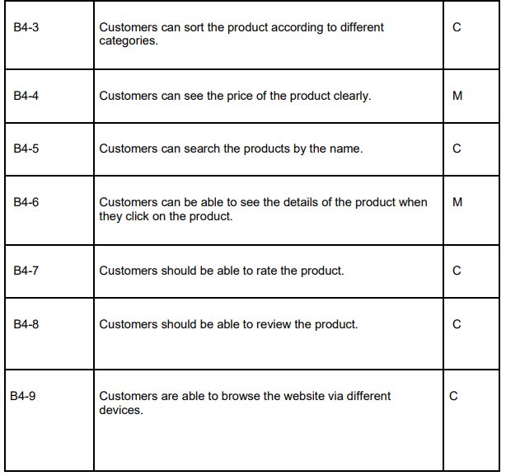

**C. Trader**

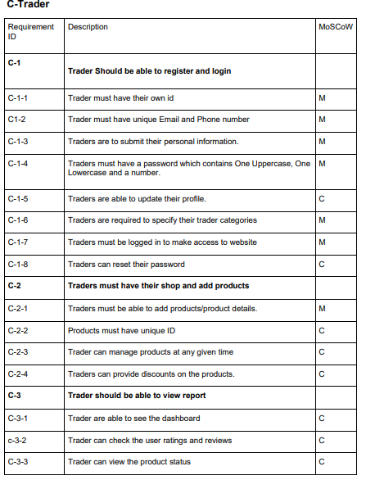

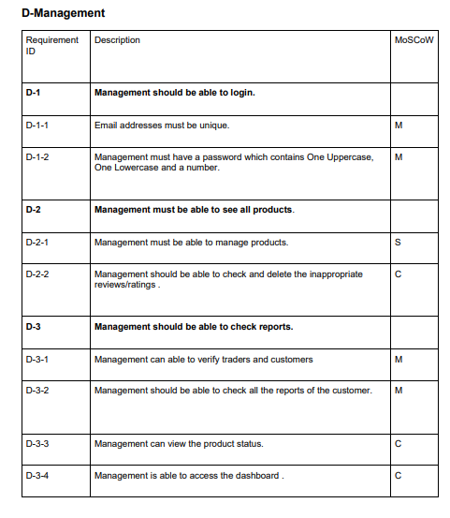

**Non-functional Requirement**

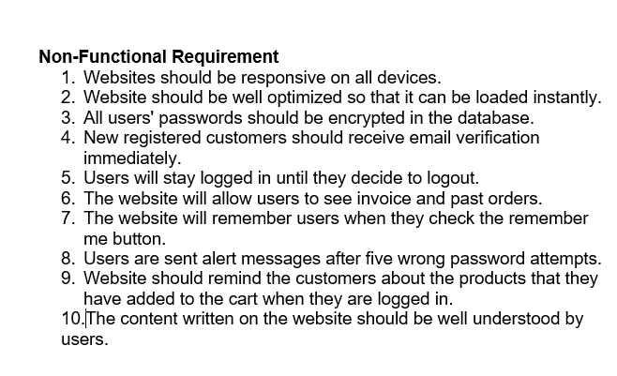

**3.4 Logo design**



**3.5 Wireframe**

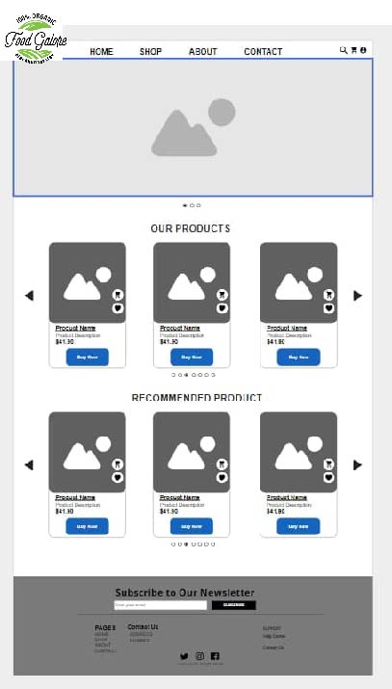

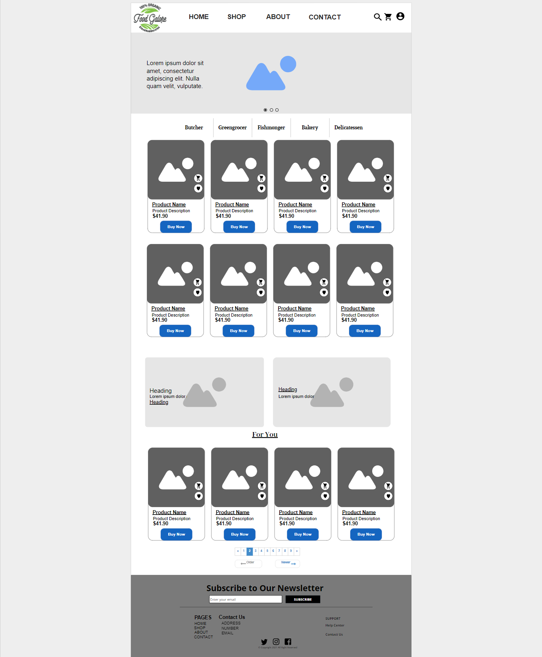

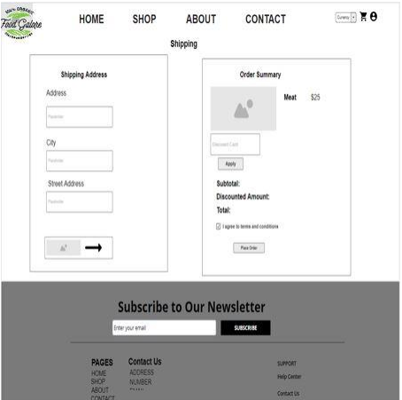

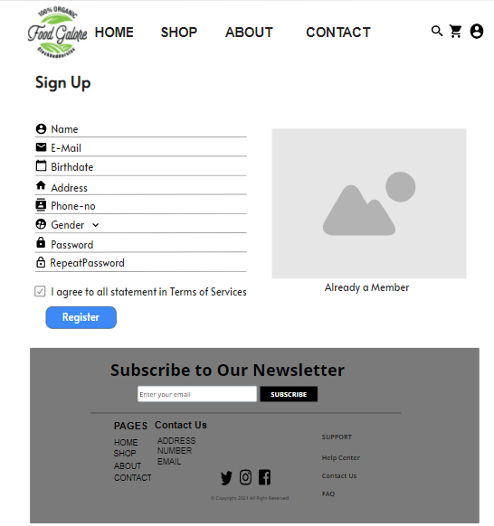

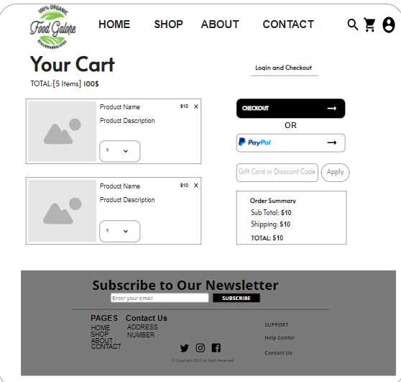

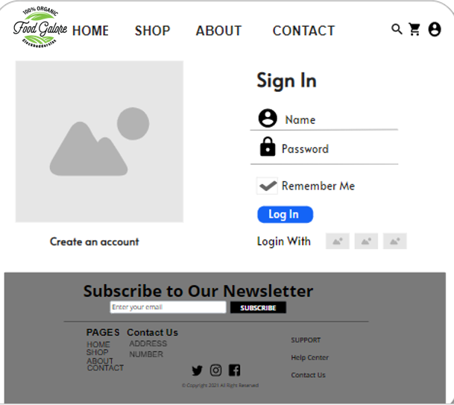

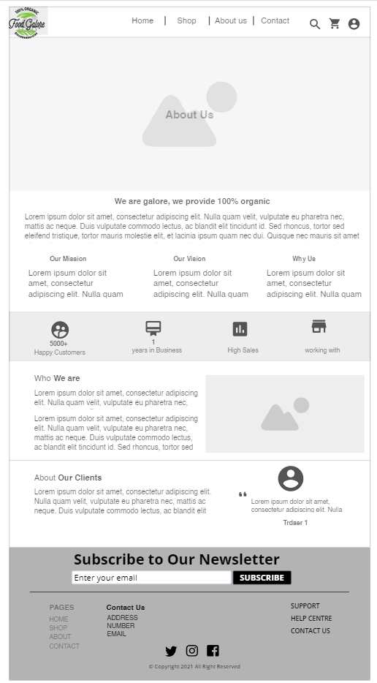

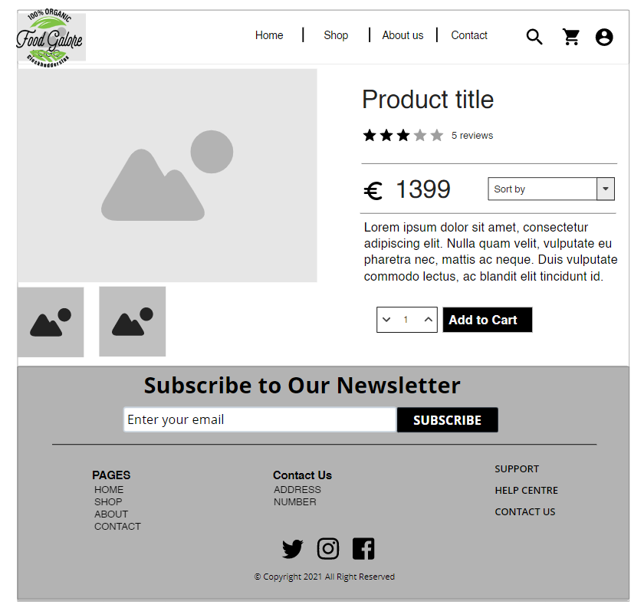

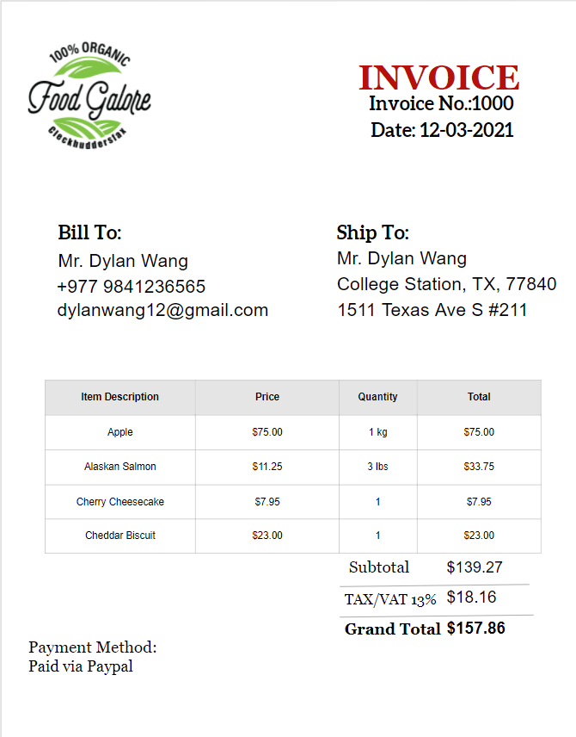

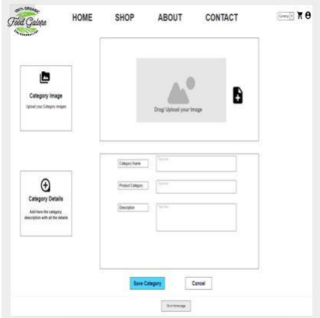

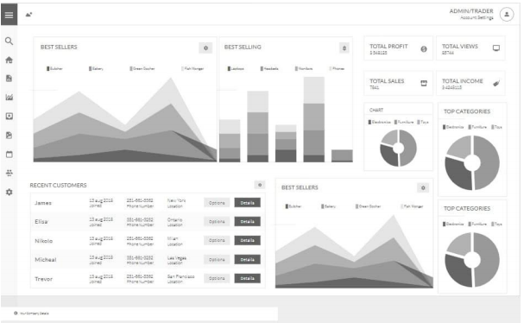

**Product Development**

**Home Page**

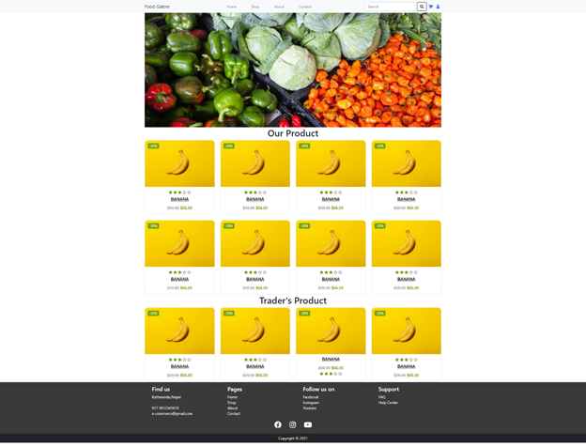

**Sign Up Page**

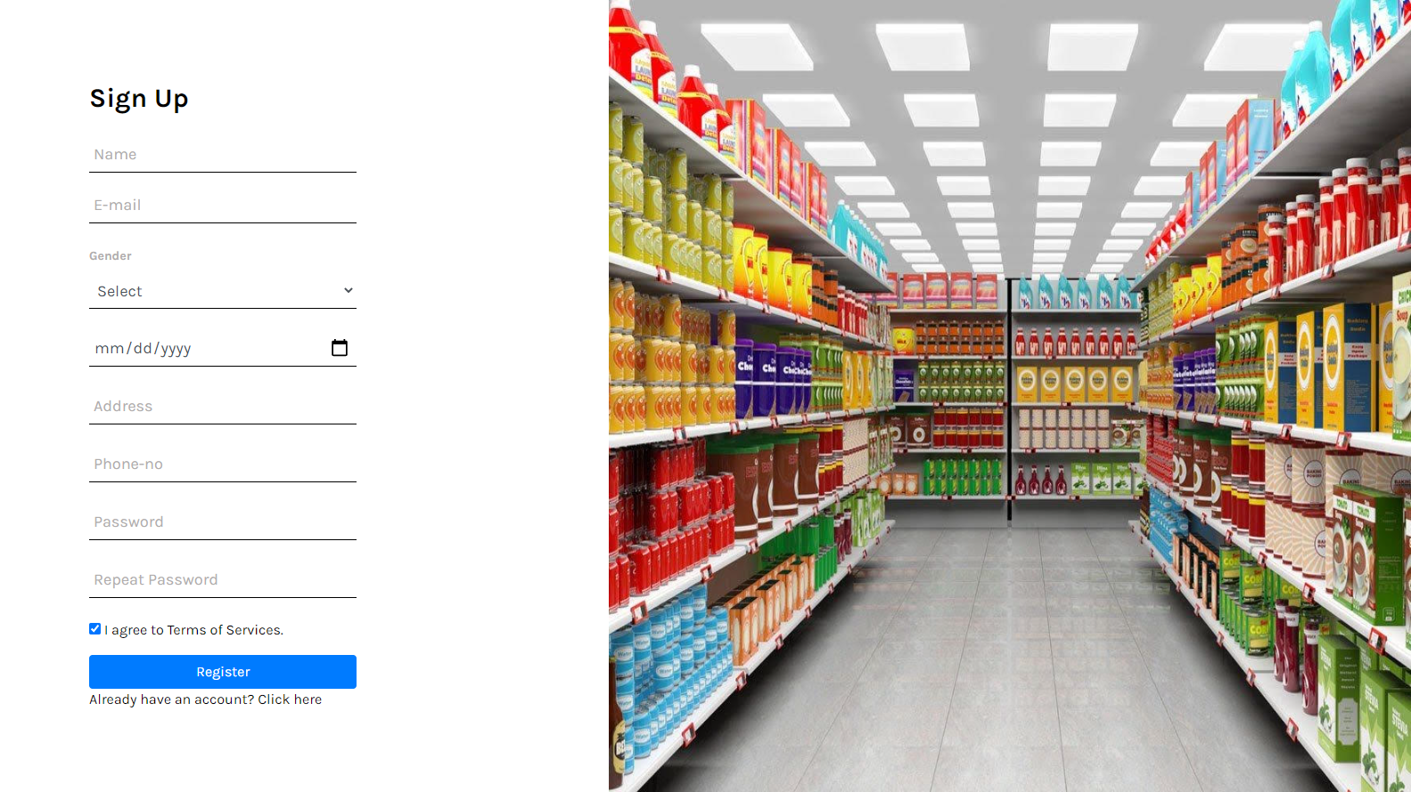

**About Us Page  
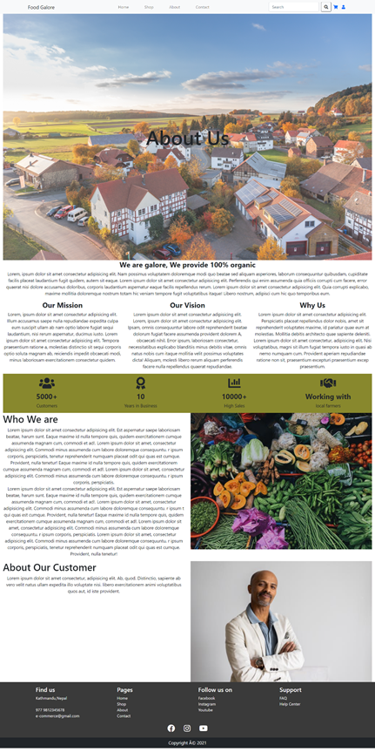**

**Sign In Page**

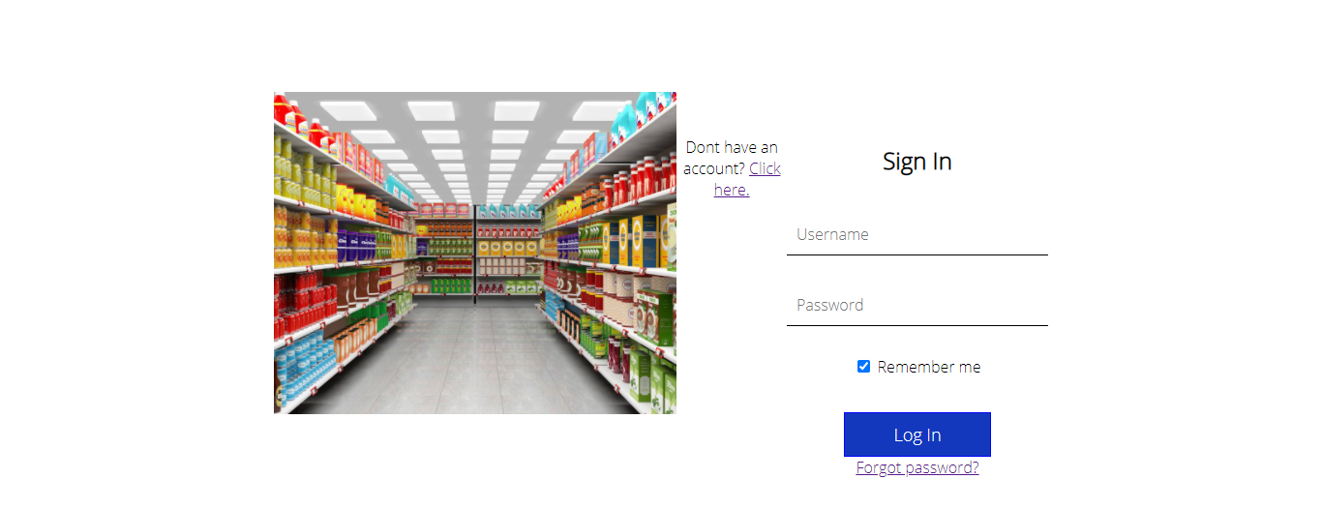

**Shop Page**

